**JINNAH UNIVERSITY FOR WOMEN**



**DEPARTMENT OF COMMERCE**

**ASSIGNMENT # 01**

Types of Business Communication

**SUBMITTED BY**

Wajiha Muhammad Ismail

**DEGREE PROGRAM**

BS (II)

**SUBJECT**

Business Communication

**SUBMISSION DATE**

Sept 08, 2020

**SUBMITTED TO**

Miss Uzma

# **What Is Business Communication?**

Communication is the process of sharing information between management, employees and customers of an organization. It is essential for every organization. Effective communication between management and employees can help the organization to fulfil their goals easily and it will resultant as a success and growth of an organization.

# **Different Types of Business Communication**

There are **four main types** of business communications.

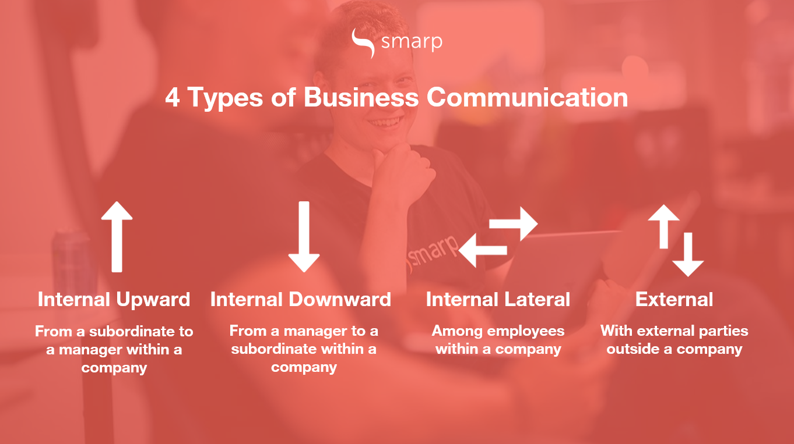

### 1. **Internal upward communication**

According to the organizational hierarchy, this internal upward communication means information flows in upward direction from subordinate to manager. For the examination or getting understandings of running operations in the organization. For getting the information from subordinate or employees they usually use surveys, feedback, forms and reports and send them to their managers or team leaders.

For example, a marketing report may include statistics such as total website visitors or social media engagement.



### 2. **Internal downward communication**

This internal downward communication means information flows in downward direction from superior to subordinates in the form of letters, memo or verbally. While leader communicating to their employees, they keep their communication clear and professional.

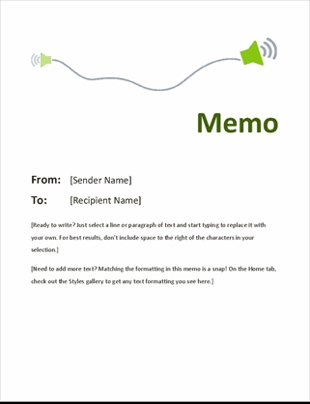An example of this type of communication may include a memo regarding a new company operations procedure such as safety requirements and new regulations.

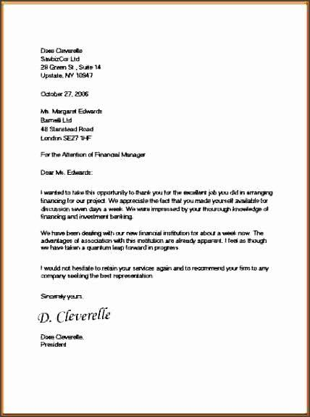

### 3. **Internal lateral communication**

Internal lateral communication means information flows between employees through chats, messages, emails with the help of software. In this way, information revolves within the organization between the departments more than other communication methods. Moreover, frequent communication among employees play an important role for employee engagement and productivity.



### 4. **External communication**

****External communication means information flows outside the organization with external parties includes vendors, customers or partners. On regular basis, external communication use less than the all internal communications.